**Hands on 1: Create a Spring Web Project using Maven**

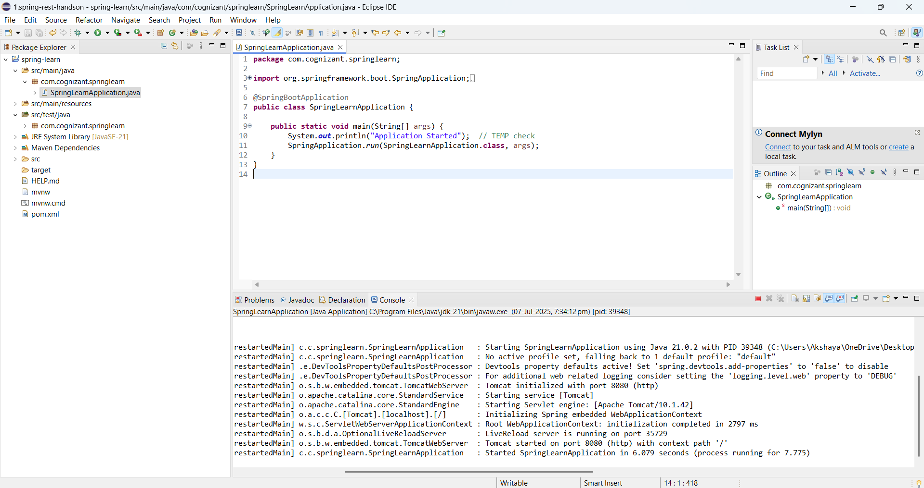

**Hands on 2: Spring Core – Load SimpleDateFormat from Spring Configuration XML**

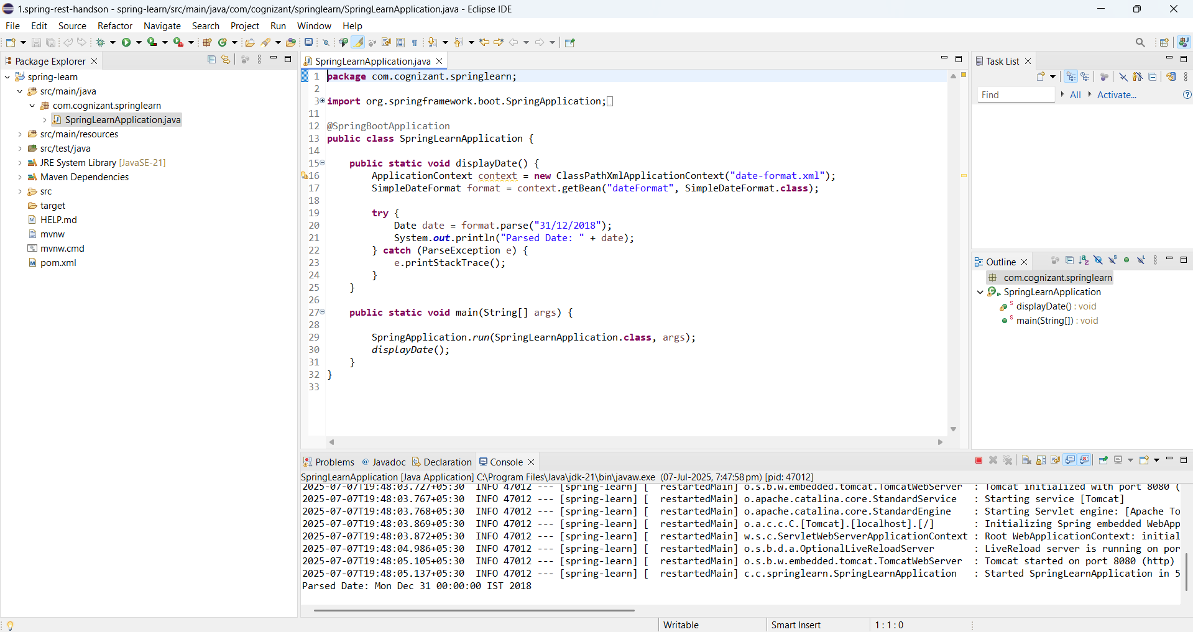**Hands on 3**

**Spring Core - Incorporate Logging**

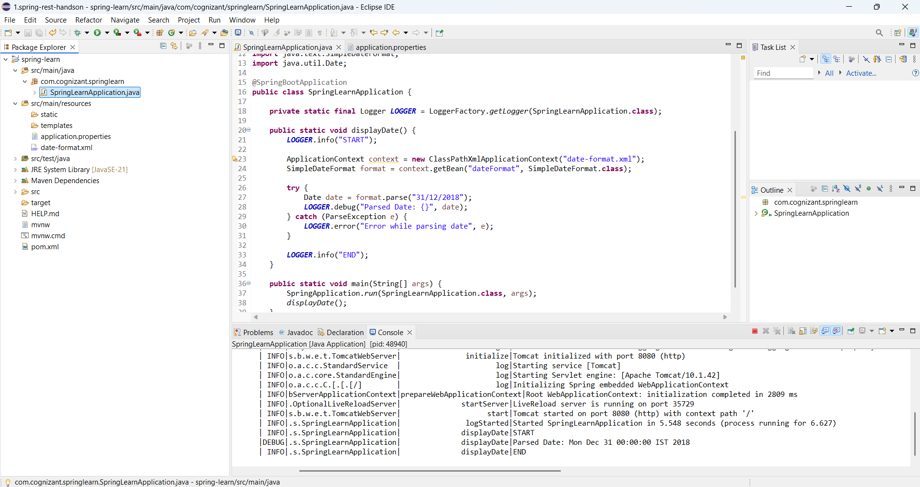

**Hands on 4**

**Spring Core – Load Country from Spring Configuration XML**

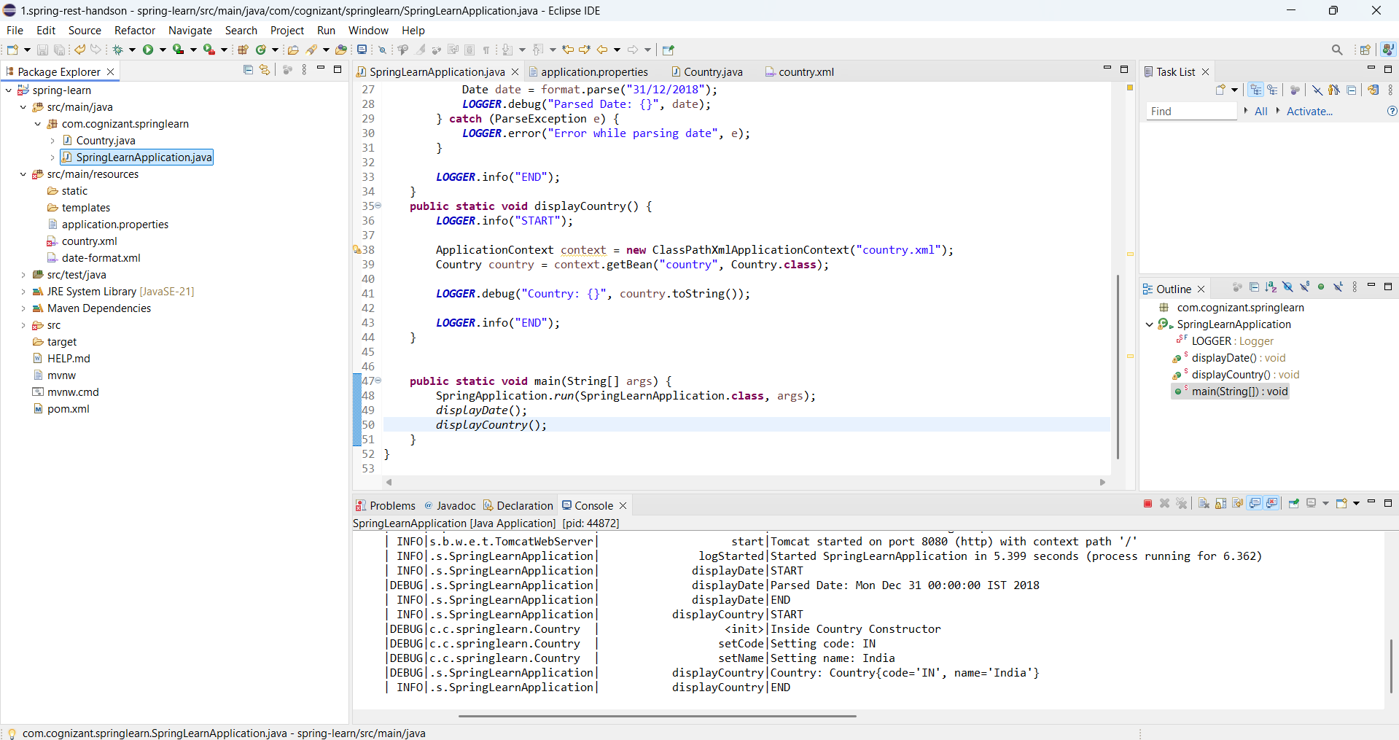

**Hands on 5**

**Spring Core – Demonstration of Singleton Scope and Prototype Scope**

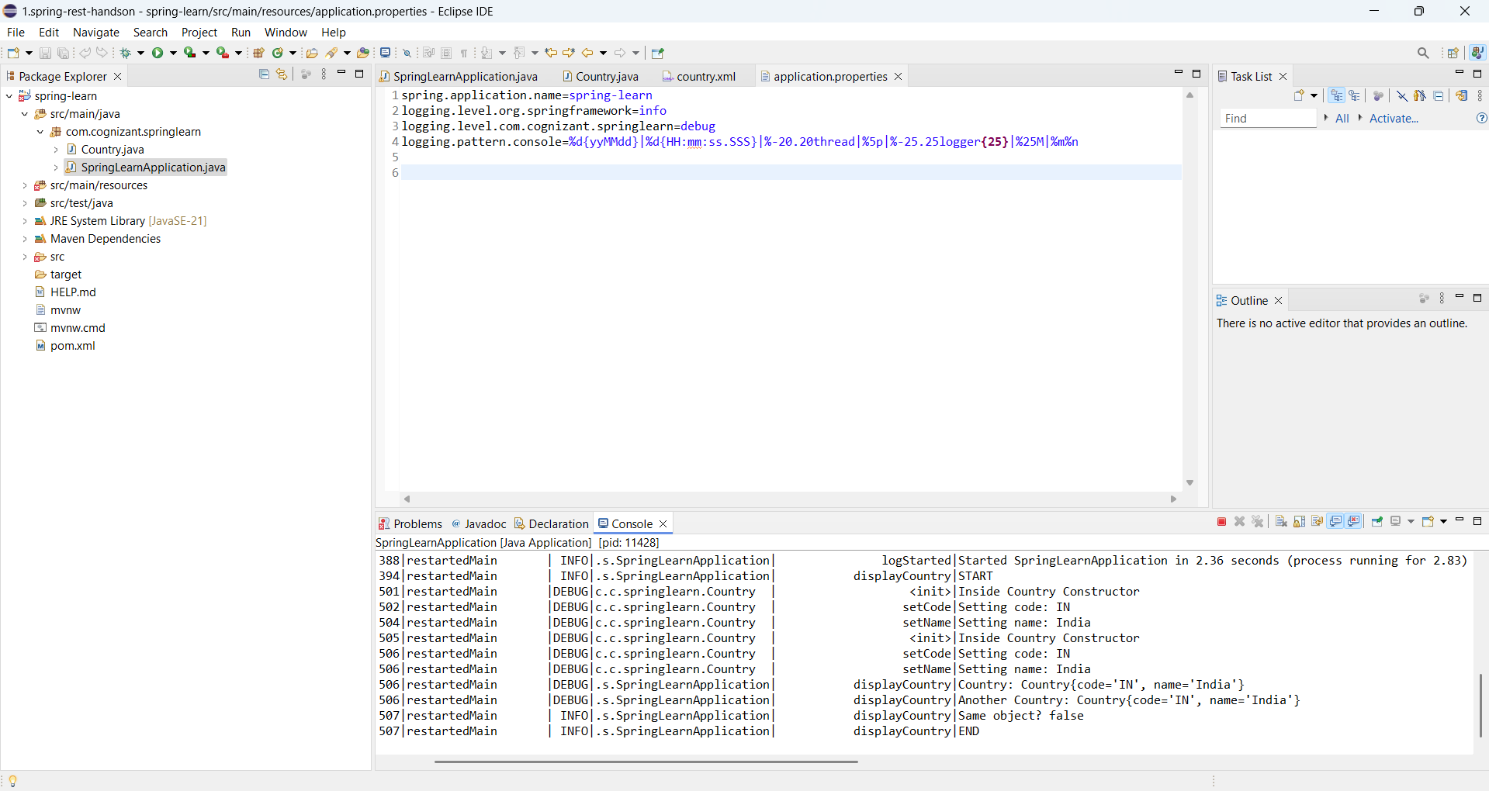

**Hands on 6**

**Spring Core – Load list of countries from Spring Configuration XML**

